Twenty-Ninth Sunday in Ordinary Time
October 17/18, 2020
St. Michael Poplar Springs, Mount Airy, MD

Public Masses Saturday, October 10, at 5:00 p.m.
Sunday, October 11 at 8:00 a.m. and at 10:30 a.m.

Welcome to Saint Michael Poplar Springs for Public Mass.

There will be one more OUTDOOR MASS! It will take place next Sunday, October 25, at 12:30 p.m. If you have been waiting for the chance to return the celebration of the Eucharist when you feel safe, perhaps an outdoor celebration will be the opportunity you and your family have needed. Make plans to attend – bring chairs or a blanket and wear your mask!

The Cornerstone Breakfast “To Go” will take place next Sunday from 8:30 a.m. until noon. Stop in the multi-purpose room/gym to pick up breakfasts - $10.00 each. Perhaps you could plan a late breakfast and arrange to go to 12:30 Mass, still observing a one hour fast before Communion! No need to RSVP.

Since we do not “take up” a collection, we usually remind you about checking into on-line giving or dropping your offering in the baskets as you leave. Please note that in the bulletin you can get information about what would have been our SECOND collection today: World Mission Sunday, and about next weekend’s SECOND collection: The Mandeville Mission. Again, there are no collections taken up, but we encourage your generosity to World Mission Sunday this weekend.

We are pleased to announce that we are now allowed to have an entrance procession and a procession out of the church after Mass ends. Also, at an outdoor Mass we can encourage congregational singing – yet a mask must still be worn. Please remember that, at the other Masses, a cantor or small group of singers will be singing the parts of the Mass we are all usually singing together. “No congregational singing” is still the instruction to be followed for indoor Mass.

The acclamations used during these weeks are from the Mass of Renewal. A link to a You Tube recording Mass of Renewal is listed at the end of the worship aid, should you want to learn it on your own. If you are at home watching the live-stream of 10:30 Mass, please sing out! You will find the music you need in this worship aid.

Our important regular announcements…
- Continue to make your reservation for needed seats on EVENTBRITE
- Observe social distancing while here and as you return to your car.
- Wear your mask covering both nose and mouth while on the parish campus.
- For Masses in the church, please note that if you arrive after Mass has begun, you may be seated in Fellowship Hall until we have a chance to move you into the Church.
- Also, if you have not made a reservation on Eventbrite, you may be seated in Fellowship Hall, as above.
- For Mass in the church there is only one set of restrooms open - those in Fellowship Hall. (The set of restrooms downstairs near the kitchen are open during outdoor Mass.)
GATHERING RITE
Entrance Song
“Christ in Me Arise”
Trevor Thomson
©2008, Trevor Thomson. Published by OCP. All rights reserved.
Reprinted under OneLicense.net #A-727260.
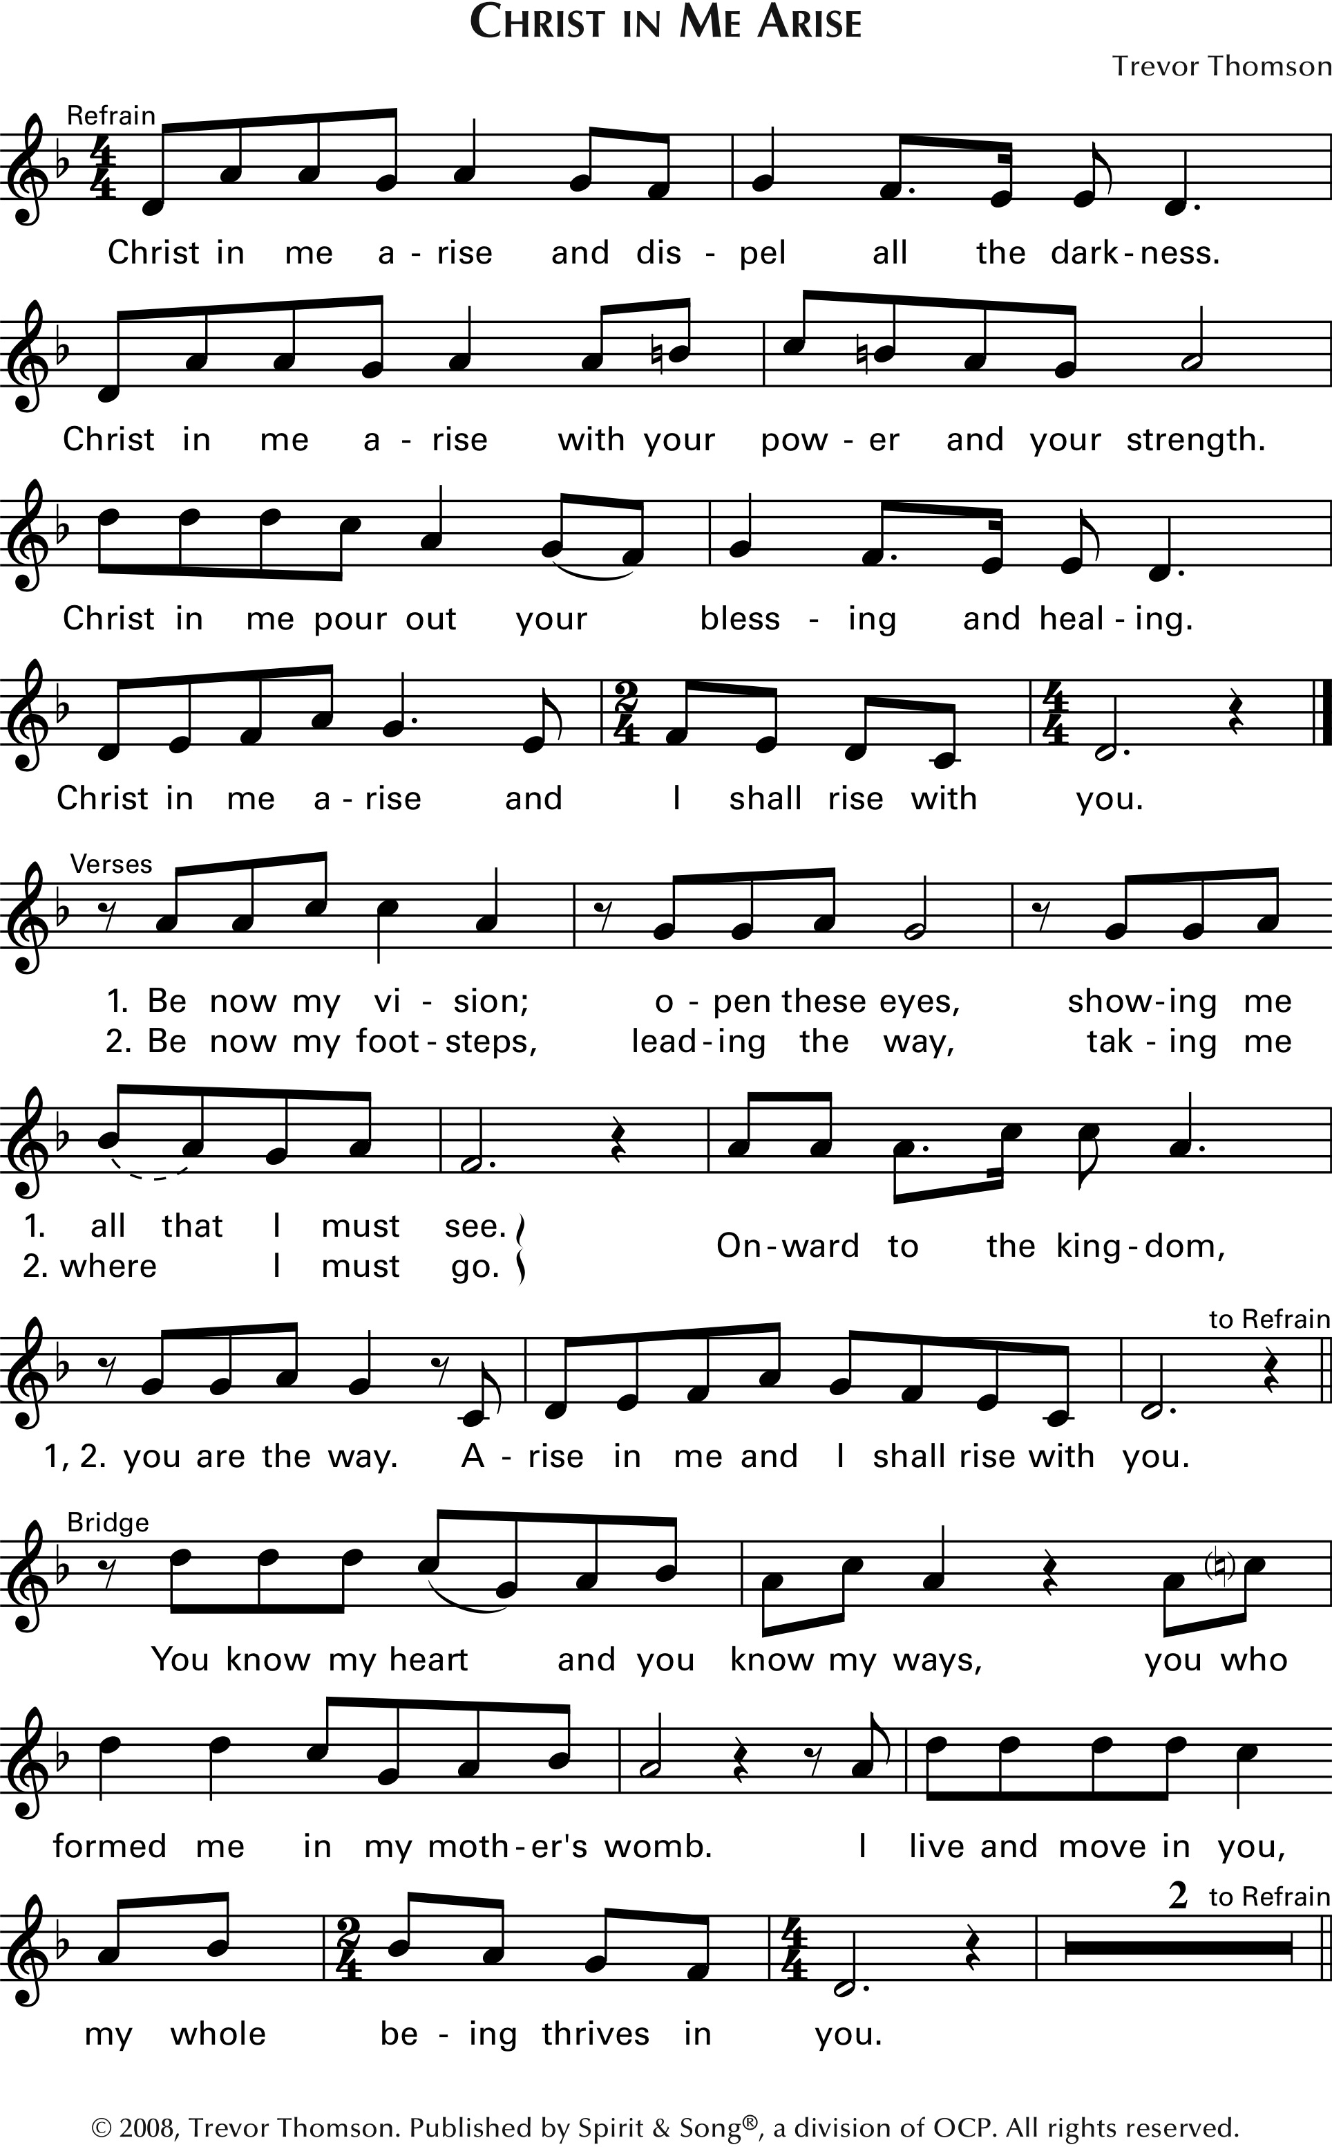

Greeting/Sign of the Cross

Penitential Act

Gloria “Glory to God” from MASS OF RENEWAL
Curtis Stephen
Text © 2010, ICEL. All rights reserved. Used with permission.
Music © 2009, Curtis Stephan. Published by OCP. All rights reserved.
Reprinted under OneLicense.net #A-727260.

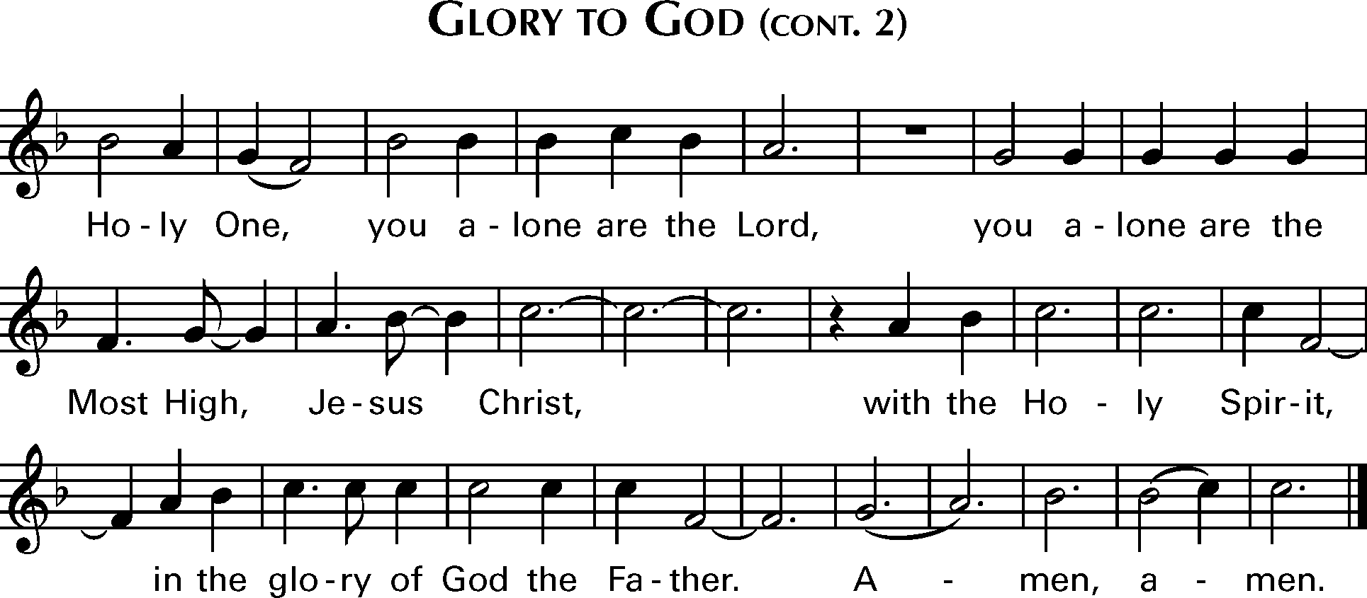

Collect

LITURGY OF THE WORD
First Reading Isaiah 45: 1, 4 - 6

Responsorial Psalm Psalm 96
“Give the Lord Glory and Honor”
Timothy Smith
Response Text: English Translation of the Psalm Response , © 1969, 1981, 1997, ICEL. All rights reserved. Used with permission.
Music © 2018, Timothy R. Smith. Published by OCP. All rights reserved. Used with permission.
Reprinted under OneLicense.net #A-727260.
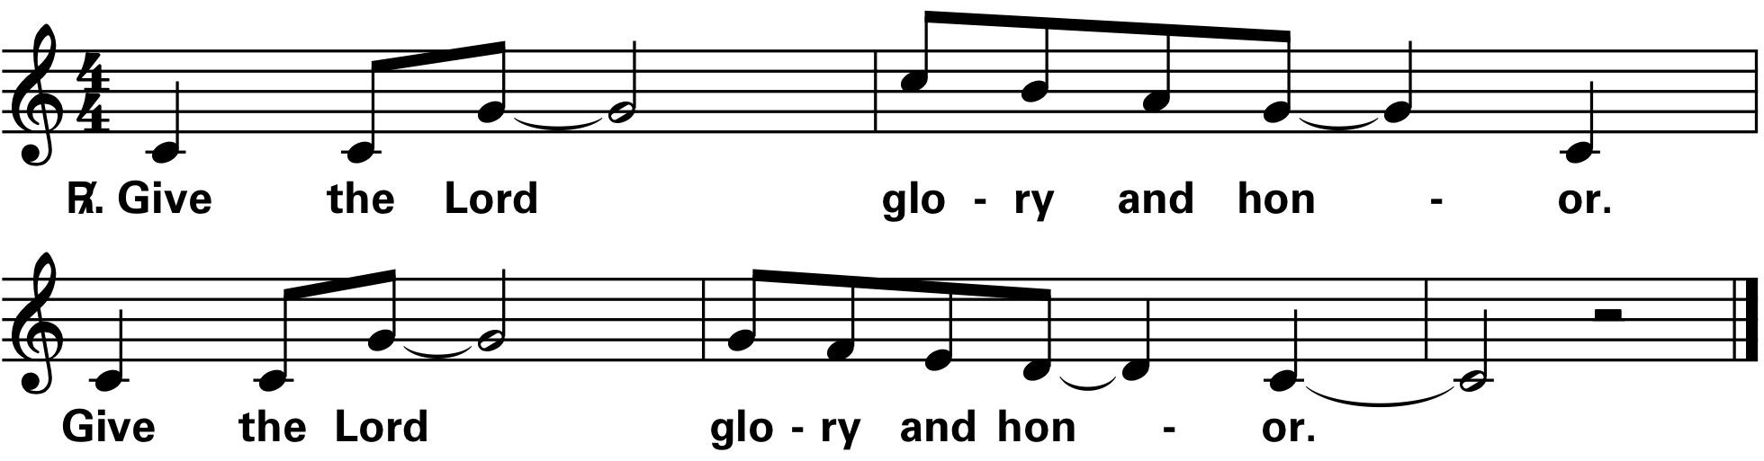

Second Reading I Thessalonians 1: 1 – 5b

Gospel Acclamation from MASS OF RENEWAL
Curtis Stephen
Music © 2009, Curtis Stephan. Published by OCP. All rights reserved.
Reprinted under OneLicense.net #A-727260. 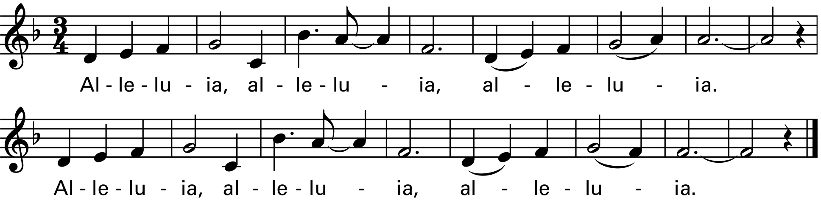

Gospel Matthew 22: 15 - 21

Homily

(After the Homily, Ted Burkhardt will speak to us about the Mandeville Mission – any gifts to be put toward the Mandeville Mission will be collected NEXT WEEKEND.)

Creed
I believe in one God,
the Father almighty,
maker of heaven and earth,
of all things visible and invisible.

I believe in one Lord Jesus Christ,
the Only Begotten Son of God,
born of the Father before all ages.
God from God, Light from Light,
true God from true God,
begotten, not made, consubstantial with the Father;
through him all things were made.
For us men and for our salvation
he came down from heaven,
and by the Holy Spirit was incarnate of the Virgin Mary,
and became man.
For our sake he was crucified under Pontius Pilate,
he suffered death and was buried,
and rose again on the third day
in accordance with the Scriptures.
He ascended into heaven
and is seated at the right hand of the Father.
He will come again in glory
to judge the living and the dead
and his kingdom will have no end.
I believe in the Holy Spirit, the Lord, the giver of life,
who proceeds from the Father and the Son,
who with the Father and the Son is adored and glorified,
who has spoken through the prophets.

I believe in one, holy, catholic and apostolic Church.
I confess one Baptism for the forgiveness of sins
and I look forward to the resurrection of the dead
and the life of the world to come. Amen.

Universal Prayer Please respond, “Lord, hear our prayer.”

LITURGY OF THE EUCHARIST
Preparation of the Gifts
Short song will be sung by the cantor or singers.
“Only This I Want”
Dan Schutte
Text based on Philippians 3: 7 – 17, 2: 15, 18. Text and Music © 1981, Daniel Schutte. Published by OCP.
All rights reserved. Used with permission. Reprinted under OneLicense.net #A-727260.
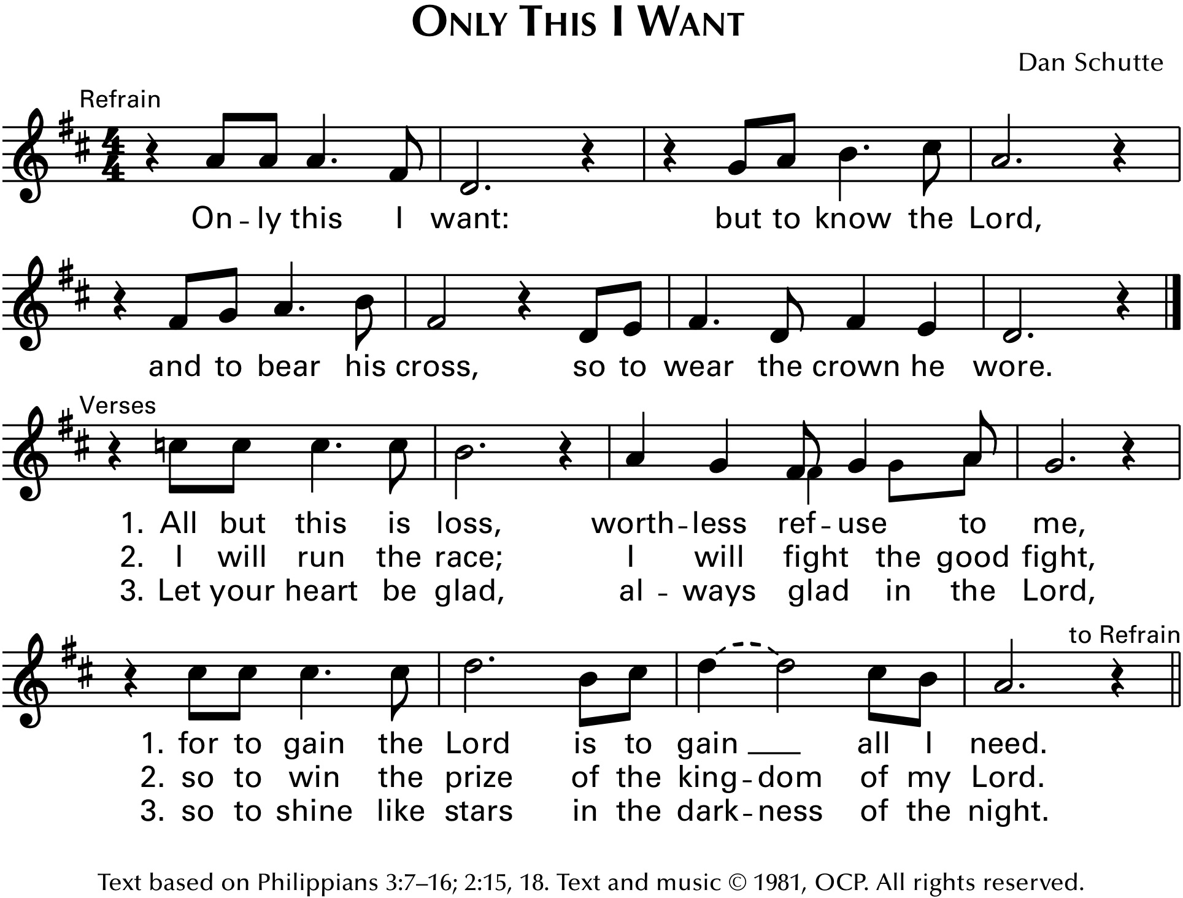
Eucharistic Prayer

NOTE THAT OUR ACCLAMATIONS WILL NOW BE SUNG BY THE CANTOR OR SMALL GROUP OF SINGERS
(At HOME or at OUTDOOR Mass, all are encouraged to sing!)

Acclamations from MASS OF RENEWAL
Curtis Stephen
Text ©2010 ICEL. All rights reserved. Used with permission.
Music © 2009, Curtis Stephan. Published by OCP. All rights reserved.
Reprinted under OneLicense.net #A-727260.
“Holy, Holy”
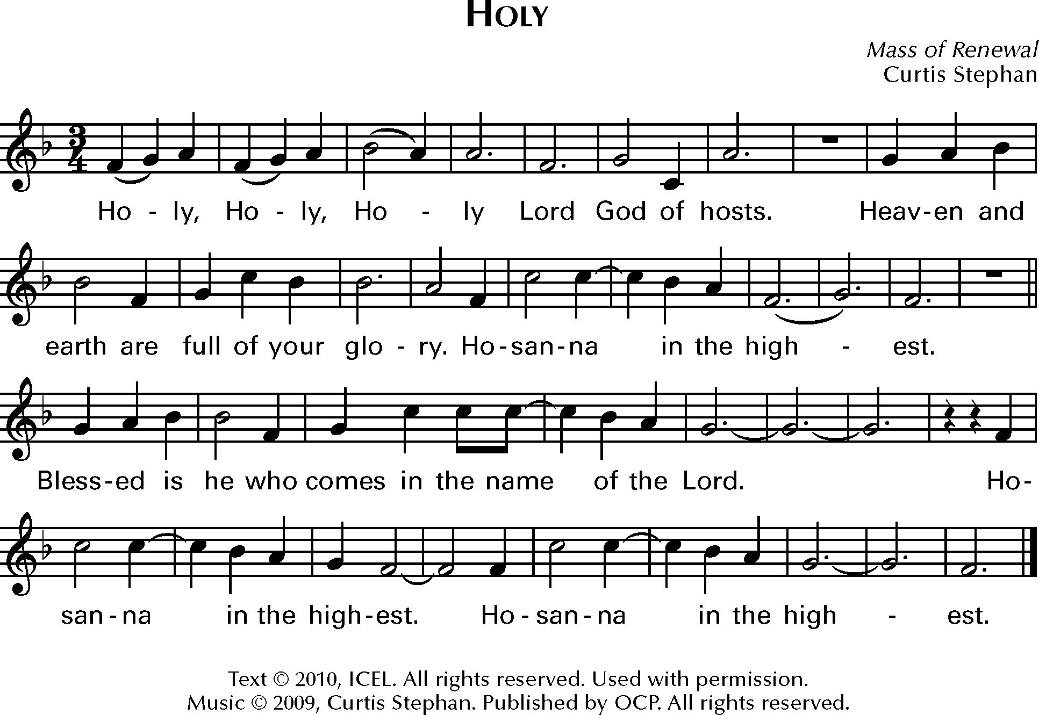

“Memorial Acclamation”
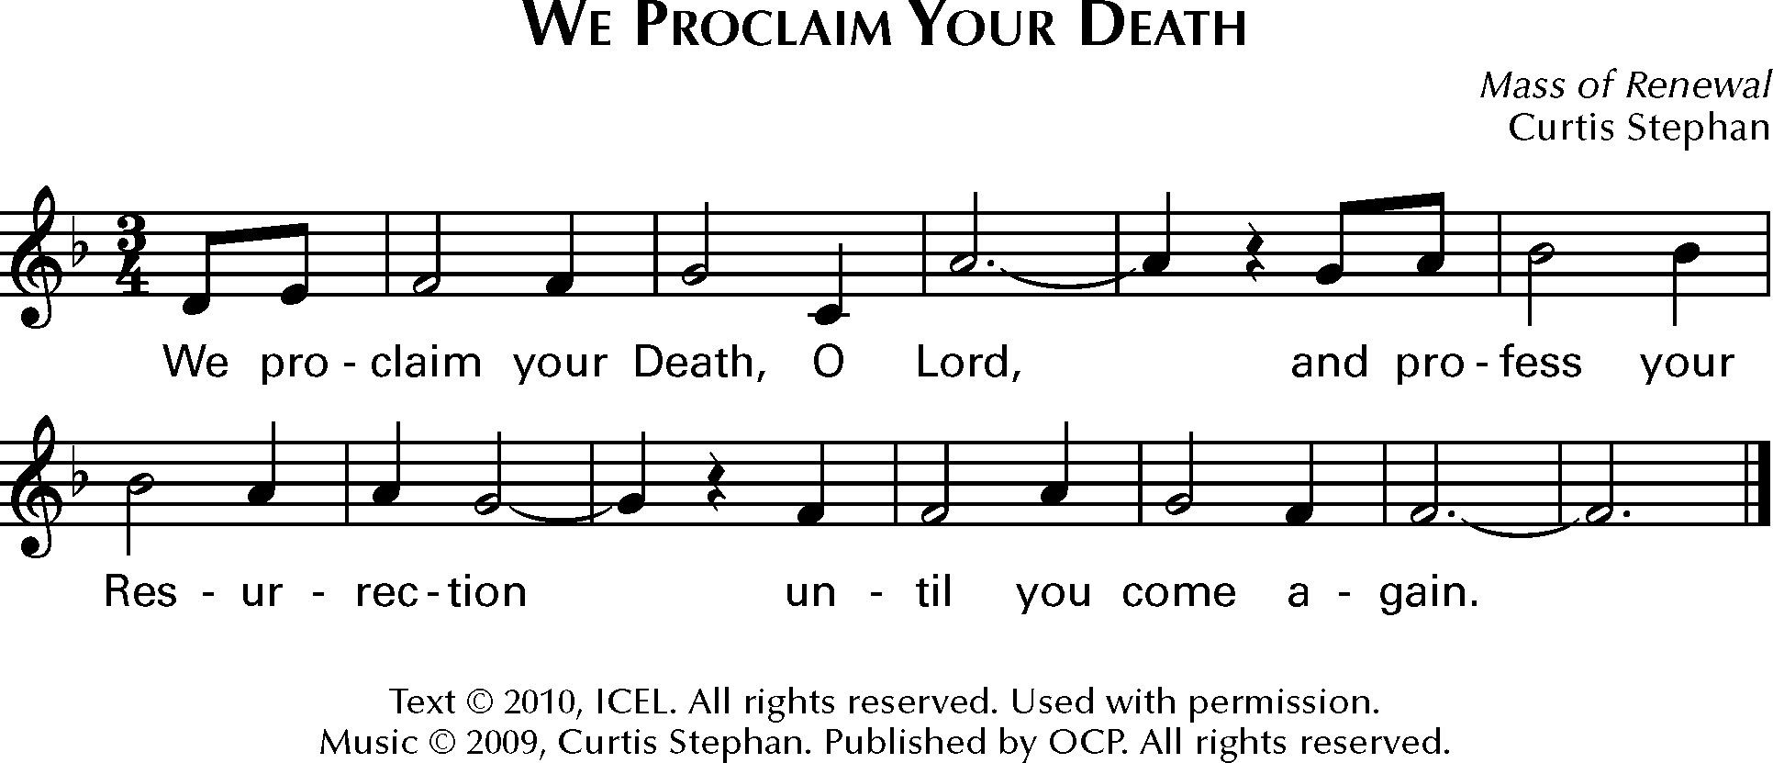

“Great Amen”
Communion Rite

The Lord’s Prayer

There will be no exchange of peace shared at public Mass
Sign of Peace
Priest: The peace of the Lord be with you always.
All: And with your spirit.

The Lamb of God
“Lamb of God” from MASS OF RENEWAL
Curtis Stephen
Text ©2010 ICEL. All rights reserved. Used with permission.
Music © 2009, Curtis Stephan. Published by OCP. All rights reserved.
Reprinted under OneLicense.net #A-727260.
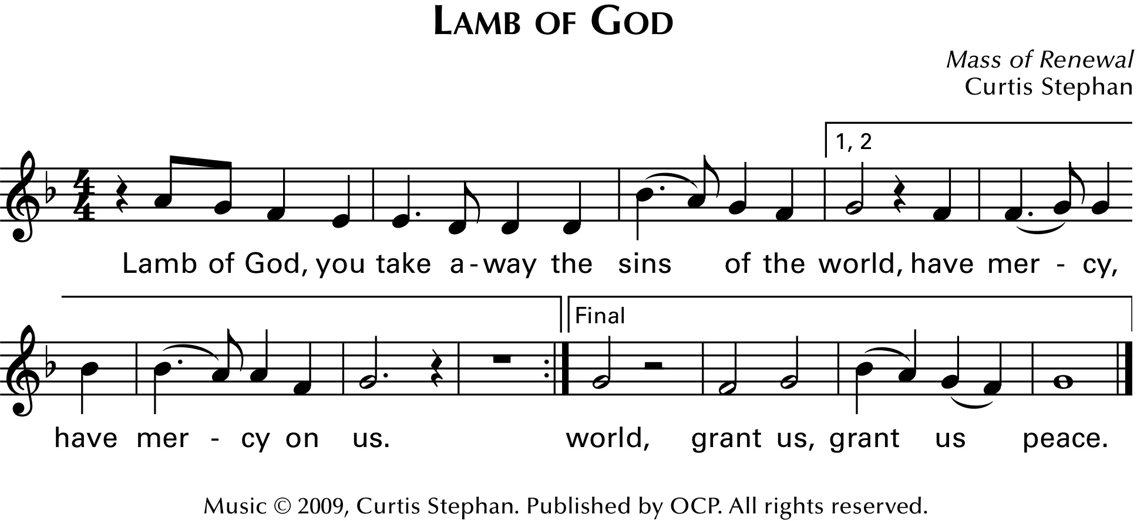
Before the priest receives Communion,
two announcements will be made
to help with the reception of Communion
under pandemic circumstances.

Please be aware of the recommendation
to receive Holy Communion in the hand
during this time
out of special concern for the vulnerable
and for those who minister to us.

Come forward as those in your section do so.
In the Church we begin with section one (nearest the
tabernacle) and section three (in the center).
(AT 10:30 we begin with sections one, three and five
(near the organ).
As soon as those sections have come forward, the other
sections will be assisted in moving into Communion lines.
- Please follow the instructions of the ushers to move into line.
- Leave your pew to the left (unless otherwise directed at the 10:30 by an usher). Be sure you wear your mask. Keep a six-foot distance from the person in front of you.
- Do not step across anyone when leaving or going back into your pew.
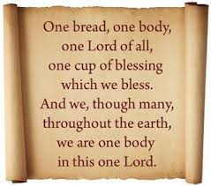

.Communion Song “One Bread, One Body”
John Foley, SJ
Text: Based on I Corinthians 10: 16-17, 12: 4, 12-13, 20; Galatians 3: 28; Ephesians 4: 4–6. The Didache 9.
Text and music ©1978, John B. Foley, SJ and OCP. All rights reserved.
Reprinted under OneLicense.net #A-727260.

Prayer after Communion
CONCLUDING RITES

Announcements
** We will celebrate another OUTDOOR MASS next SUNDAY, October 25, at a special time – 12:30 p.m., weather permitting. Bring a chair or blanket and wear your mask.
**Next Weekend will be the Cornerstone Breakfast – To Go. Serving from 8:30 until Noon. You could even have breakfast before 12:30 Mass! $10.00. Reservations are NOT needed.
** This year All Saints Day will be on a Sunday. Check out the bulletin to see a special 10:30 Mass “event” for children!
**Please remember the offertory baskets near the exits. We are grateful for your continued generosity. Also, note that this weekend we give to World Mission Sunday and next weekend begins our annual giving campaign for the Jamaica mission that will be held in 2021.
**Father will process out first today, to instrumental music. Once he has left, the back rows of each section may begin leaving.
Dismissal

Thank you for your participation
in today’s celebration of the Mass.

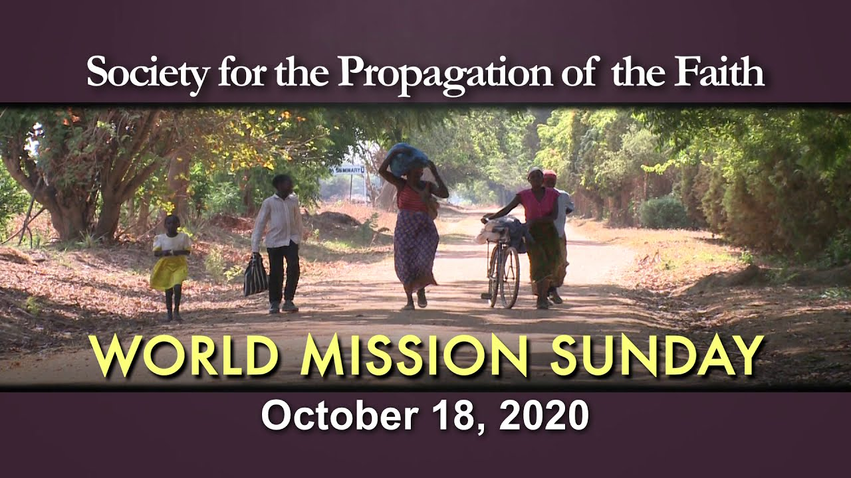

If you wish to listen to the Acclamations used in our Masses beginning today, please go to: https://www.youtube.com/watch?v=9bpQzIaHbUM
Glory to God .48 We Proclaim… 6.36
Gospel Acclamation 3.02 Great Amen 8.03
Holy, Holy 5.42 Lamb of God 8.19

