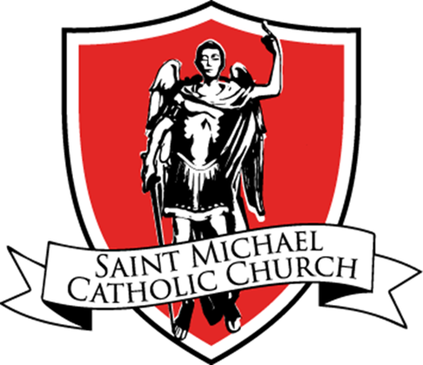 St. Michael Catholic Church
FACILITIES USE REQUEST FORM
This form must be submitted for approval to the Parish Secretary prior to all fundraisers, events or meetings you wish to schedule at St. Michael facilities.

Name of Event: ___________________________________________________________________________
Sponsoring Group/Committee: ______________________________________________________________
Group/Committee Contact Name/Email: ____________________________________________________
Start Date:______________ End Date:______________ Start Time: ______End Time: _____

Facilities needed: □ Library Event:
□ Historic Chapel □ Conference Room □ Daily □ Weekly □  Monthly
□ Large Church □ Sacristy
A/V Equipment needed:
□ Using Zoom □ Set-up
□ TV/DVD □ Screen
□ Power □ Projector
□ TV □ Sound System
□ HDMI Cable

□ Narthex □ MP Room/Gym
□ Fellowship Hall □ Lower Kitchen
□ Upper Kitchen □ Food Cellar
□ Deacon’s Office □ Fields
□ Classroom (s) __________________

VIRTUS Training: All volunteers age 14 and older must have a valid VIRTUS Training Certificate on file. If you do not have one please contact Sally Amatucci at samatucci@smpschurch.org.
Does this meeting/events involve youth? □ Yes* □ No
*If YES, please give names of ALL Adult AND Youth (14+) volunteers participating in this event:
______________________________________________________________________________
Reviewed Date: __________ Approved By: ________________________ (Sally Amatucci, Virtus Coordinator)

Communications / promotions
□ Bulletin Starting: ______________ Ending: ______________
□ Webpage Starting: ______________ Ending: ______________
Date Posted: _____________ By: _____________
Display (Inside):
□ Narthex □ Fellowship Hall
□  RE Foyer □ MP Room/Gym
□ Library □ Marque

Date Posted: ______ By: ____________
Display (Community):
□ Signs Around Town
□ Mt. Airy Messenger Newspaper
□ Frederick Newspost
Date Posted: _____ By: _____________

Social Media:
□ Face Book (FB) □ St. Michael Instagram
□ St. Michael FB page □ St. Michael Twitter
□ Mt. Airy News, Discussion, Alert & Business Group □ AOB Website/Bulletin
□ Mt. Airy & Surr. Areas Info & Business Group □ AOB Churches
□ Woodbine/Lisbon Community Group □ Catholic Review
Date to Post 1st Time: ______________ 2nd Time: ______________ 3rd Time: _________
Date Posted: _____________ By: _____________
Flocknote (Mass Email):
□ All Parishioners □ O.W.L.S. of St. Michael
□ Faith Formation □ Men of St. Michael
□ Middle School Families □ Women of St. Michael
□ High School Families □ Preschool Families
□ Young Adults □ Other __________
Date to Send: _____________ Date Posted: _____________ By: _____________

Date Received:____________________________ By:_______________________

